Goals:

* **Access multiple search engines at once (Versatility)**
  + Retrieving data from the internet
  + Sending data to search
  + No Advertisements
  + Ease of access to data (more options)
  + Customizable UI
  + Simplicity
  + No user account logins
  + No autofill
  + Transparency
  + Security (VPN and Passwords)

Each link clicked will open in the corresponding browser or specified browser (It’s just a webbrowser in Windows Visual Studio)

* Find place for text/marker and throw it on all the other search bars (Graphical) (GOOFY)

1. 3 Search Engines (Google, Edge, Firefox)
   1. Textbox, Browser (Image, List of Links)
   2. Download Page
   3. More Search Engines (Scalable Graphical Interface)
      1. Brave
      2. DuckDuckGo
2. 2 Media Search Bars (Doesn’t need Account: Youtube, Spotify)
   1. More Search Engines
      1. Discord & Public Servers
      2. Google Scholar
      3. Meriam Webster
      4. Oxford Dictionary
3. 2 AI (Needs AccountChatGPT, Bing Images, EBSCO)
   1. User Integration/Fake a User (VPN or TempMail)

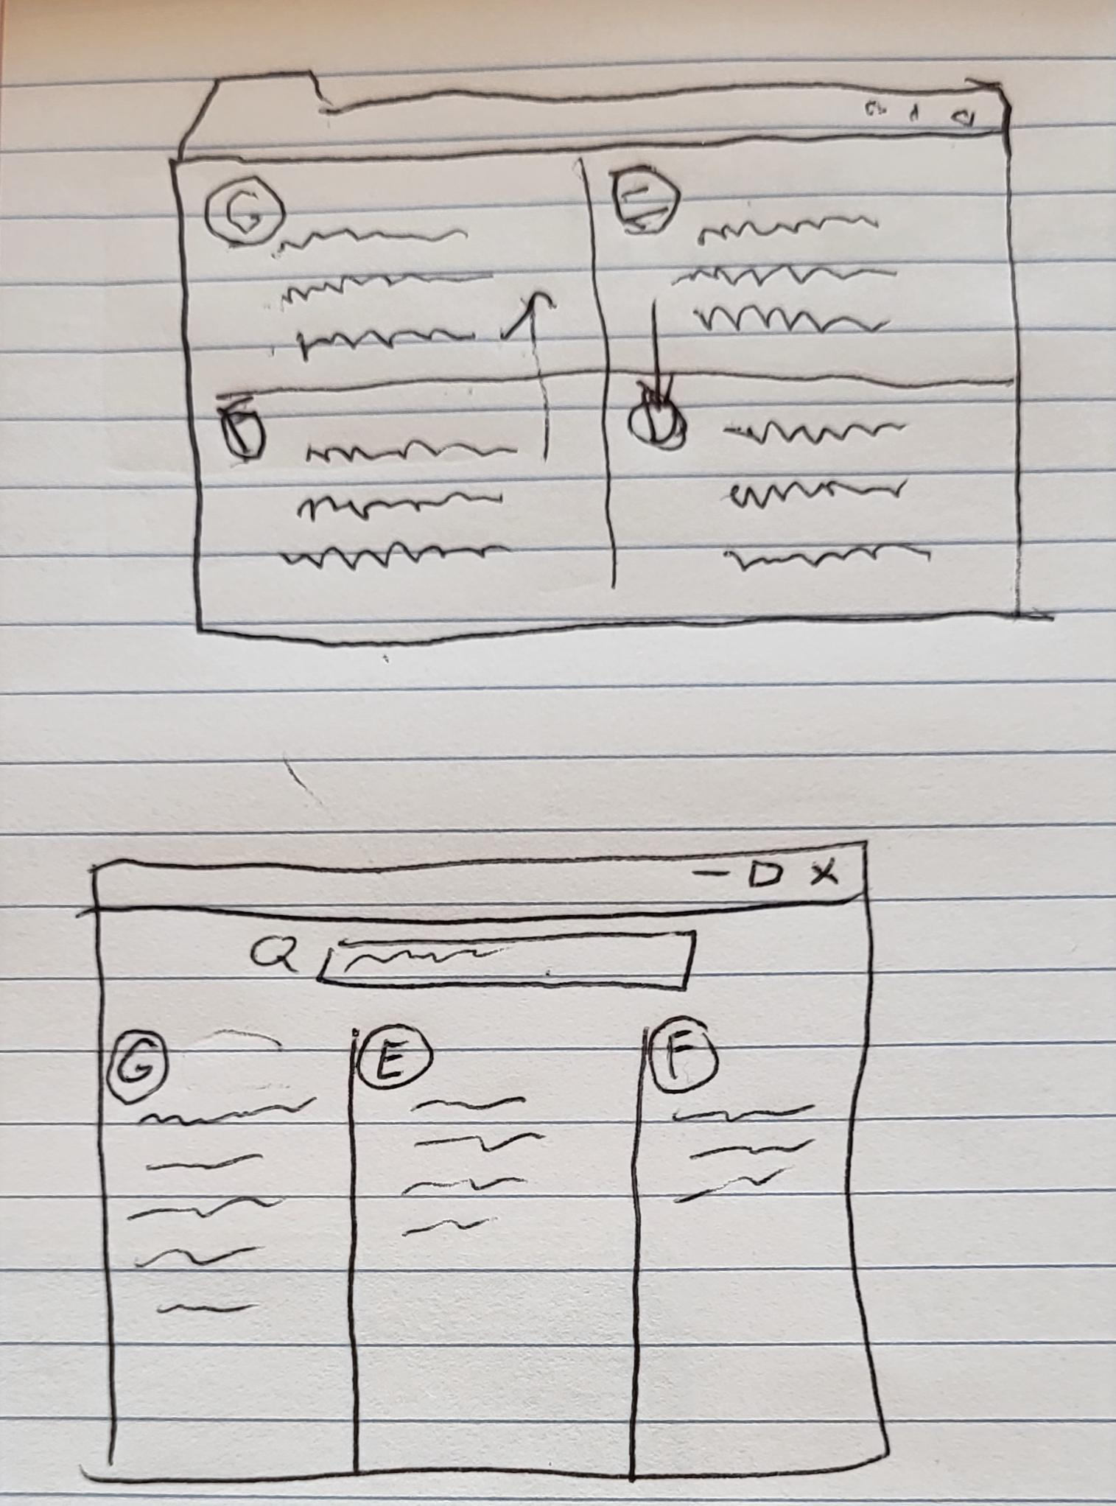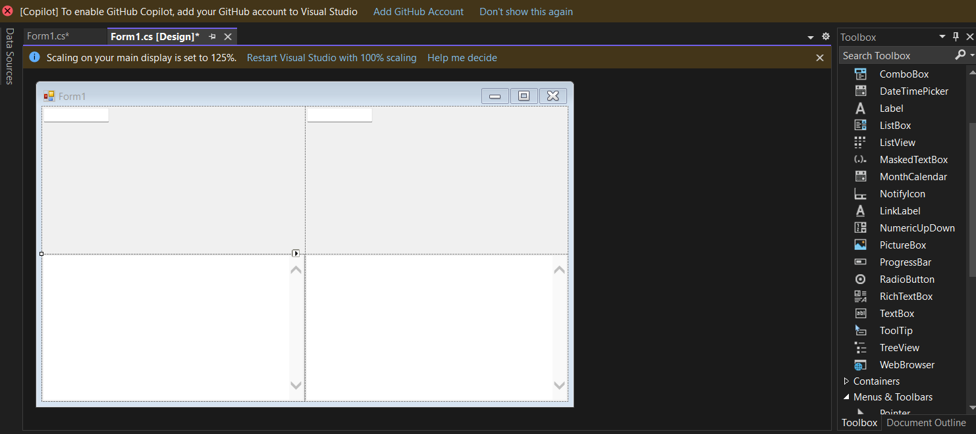

**SLIDES**

**Product Desc.: Simple Browser for Search Engines. A Simple Search Engine Tool**

1st Base Goal : 3 search engines

Making the basic Window: Textbox, Browser (Image, List of Links)

Secondary Download Page: Use Existent Internet Access to Download Browsers)

Extra: Add More/Infinite Search Engines (Versatility)

2nd Goal: 2 Media Bars

Add APIs that aren't available

3rd Goal (If Possible): User Integration

Access Search Bars that need a Login

Questions